SUPER STORE SALES
SQL QUERIES
- Total Sales
SELECT ROUND(SUM(Sales),2) AS Total_Sales
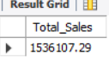
FROM superstore_sales;

- Total Quantity
SELECT SUM(Quantity) AS Total_Quantity
FROM superstore_sales;
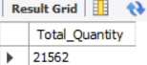

- Total Profit
SELECT ROUND(SUM(Profit),2) AS Total_Profit
FROM superstore_sales;
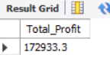

4 : Average Delivery Days
SELECT ROUND(
AVG(
DATEDIFF(
STR_TO_DATE(`Ship Date`,'%d-%m-%Y'),
STR_TO_DATE(`Order Date`,'%d-%m-%Y')
)
),2
) AS Avg_Delivery_Days
FROM superstore_sales;
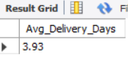

Donut Chart : Sales by Segment
SELECT
Segment,
ROUND(SUM(Sales),2) AS Sales
FROM superstore_sales
GROUP BY Segment
ORDER BY Sales DESC;
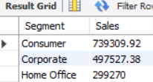

Sales by Payment Mode
SELECT
`Payment Mode`,
ROUND(SUM(Sales),2) AS Sales
FROM superstore_sales
GROUP BY `Payment Mode`
ORDER BY Sales DESC;
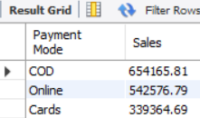

Sales By Region
SELECT
Region,
ROUND(SUM(Sales),2) AS Sales
FROM superstore_sales
GROUP BY Region
ORDER BY Sales DESC;
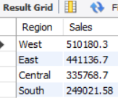

Monthly Sales by Year
SELECT
YEAR(STR_TO_DATE(`Order Date`,'%d-%m-%Y')) AS Year,
MONTHNAME(STR_TO_DATE(`Order Date`,'%d-%m-%Y')) AS Month,
MONTH(STR_TO_DATE(`Order Date`,'%d-%m-%Y')) AS Month_No,
ROUND(SUM(Sales),2) AS Sales
FROM superstore_sales
GROUP BY Year, Month, Month_No
ORDER BY Year, Month_No;
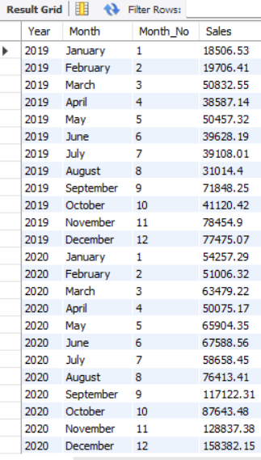

Monthly Profit by Year
SELECT
YEAR(STR_TO_DATE(`Order Date`,'%d-%m-%Y')) AS Year,
MONTHNAME(STR_TO_DATE(`Order Date`,'%d-%m-%Y')) AS Month,
MONTH(STR_TO_DATE(`Order Date`,'%d-%m-%Y')) AS Month_No,
ROUND(SUM(Profit),2) AS Profit
FROM superstore_sales
GROUP BY Year, Month, Month_No
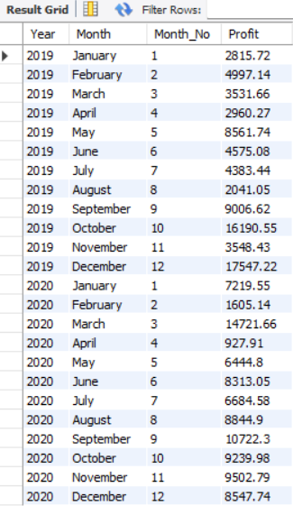
ORDER BY Year, Month_No;

Sales by Category
SELECT
Category,
ROUND(SUM(Sales),2) AS Sales
FROM superstore_sales
GROUP BY Category
ORDER BY Sales DESC;
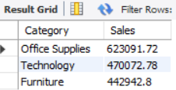

Sales by Ship Mode
SELECT
`Ship Mode`,
ROUND(SUM(Sales),2) AS Sales
FROM superstore_sales
GROUP BY `Ship Mode`
ORDER BY Sales DESC;
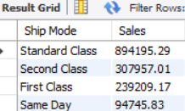

Sales by Sub-Category
SELECT
`Sub-Category`,
ROUND(SUM(Sales),2) AS Sales
FROM superstore_sales
GROUP BY `Sub-Category`
ORDER BY Sales DESC
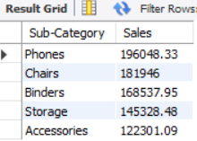
LIMIT 5;

Sales by Region
SELECT
Region,
ROUND(SUM(Sales),2) AS Sales
FROM superstore_sales
GROUP BY Region;
